Program 1:

Model a simple HTML file to demonstrate the use of different tags.

Program Code:

<html>

<head>

<title>html page</title>

</head>

<body bgcolor="grey">

<center><h1><b><u>HTML</u></b></h1></center>

<p>The hypertext markup language or HTML is the standard markup language for documents designed to the displayed in web browser.it can be assisted by tecnologies such as cascading styling sheet and scripting language such as javascript.</p>

<img src="https://cdn.pixabay.com/photo/2017/08/05/11/16/logo-2582748_1280.png" alt="html symbol" width="200" height="200"></br>

<h3><center>html elements</center></h3>

<ol><li>FORMATING TAGS</li>

<ul>

<li>bold</li>

<li>superscript</li>

<li>subscript</li>

<li>underline</li>

</ul>

<li>image</li>

<li>list</li></ol>

<a href="impofhtml.html">IMPORTANCE OF HTML</a>

</body>

</html>

impofhtml.html:

<html>

<head><title>imp of html</title></head>

<body><h1><center><u>IMPORTANCE OF HTML</u></center></h1>

<p>Hypertext Markup Language, or HTML, is a programming language used to describe the structure of information on a webpage. Together, HTML, CSS, and JavaScript make up the essential building blocks of websites worldwide, with CSS controlling a page's appearance and JavaScript programming its functionality</p>

</body>

</html>

Output:

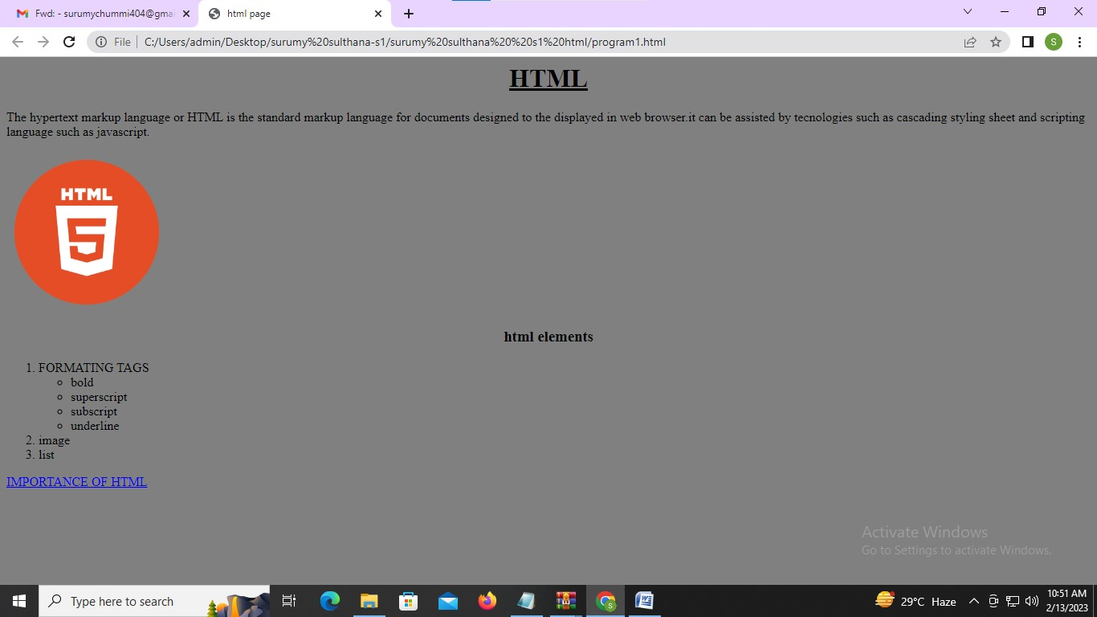

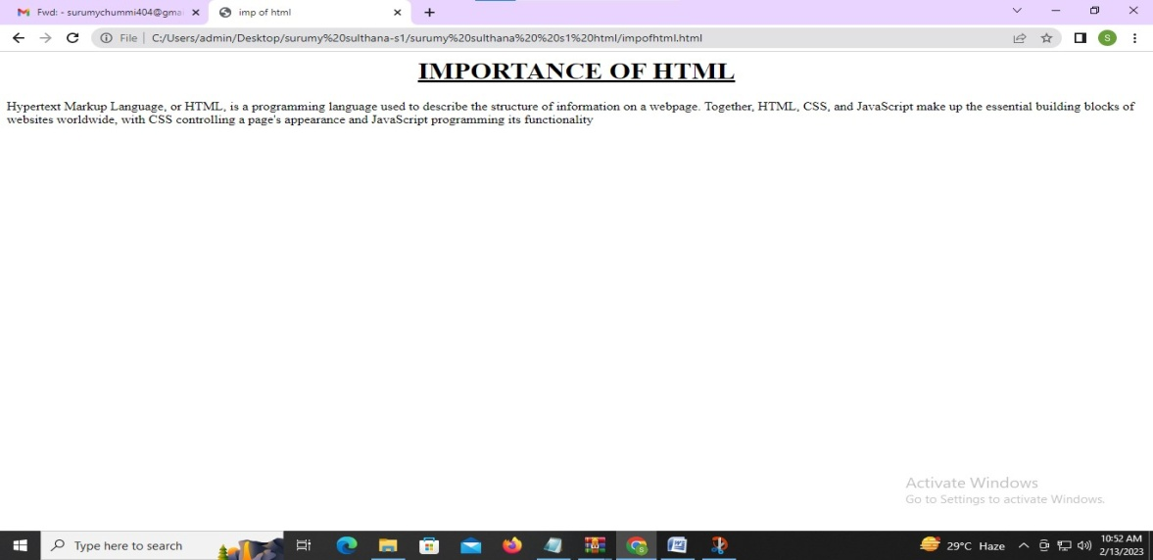

Program 2:

Create a HTML file to link to different HTML page which contains images, tables, and also link within a page.

Program Code:

<html>

<head>

<title>digital marketing</title>

</head>

<body bgcolor="blue">

<h1 style="color:white"><center><b><u>DIGITAL MARKETING</u></b></center></h1>

<p style="color:white">Digital marketing, also called online marketing, is the promotion of brands to connect with potential customers using the internet and other forms of digital communication.......

</p>

<center><img src="C:\Users\admin\Desktop\surumy sulthana-s1\surumy sulthana s1 html\html programs\dm1.jpeg" height="400" width="1000"></center>

<a href="dm.html" style="color: #8ebf42">Digital Marketing Overview: Types, Challenges, and Required Skills</a>

</body>

</html>

dm.html:

<html>

<head></head>

<body >

<h1 ><center><u>Digital Marketing Overview</u></center></h1>

<p >

The term digital marketing refers to the use of digital channels to market products and services in order to reach coustemers

</p>

<center><img src="C:\Users\admin\Desktop\surumy sulthana-s1\surumy sulthana s1 html\html programs\dm2.jpeg" height="350" width="1000"></center>

<center>

<table border="1">

<tr>

<th>Regno & Name</th>

<th>Course</th>

<th colspan="2">Mark Obtained</th>

<th>Total Mark</th>

</tr>

<tr>

<td rowspan="4" align="center">22011 <br>x</td>

<td rowspan="2" align="center">ML</td>

<td>Internal</td>

<td>39</td>

<td rowspan="2">89</td>

</tr>

<tr>

<td>External</td>

<td>50</td>

</tr>

<tr>

<td rowspan="2" align="center">CN</td>

<td>Internal</td>

<td>35</td>

<td rowspan="2">80</td>

</tr>

<tr>

<td>External</td>

<td>45</td>

</tr>

<tr>

<td colspan="4" align="right">Grand Total</td>

<td>169</td>

</tr>

</table>

</center>

<a href="program2.html">home</a>

</body>

</html>

Output:



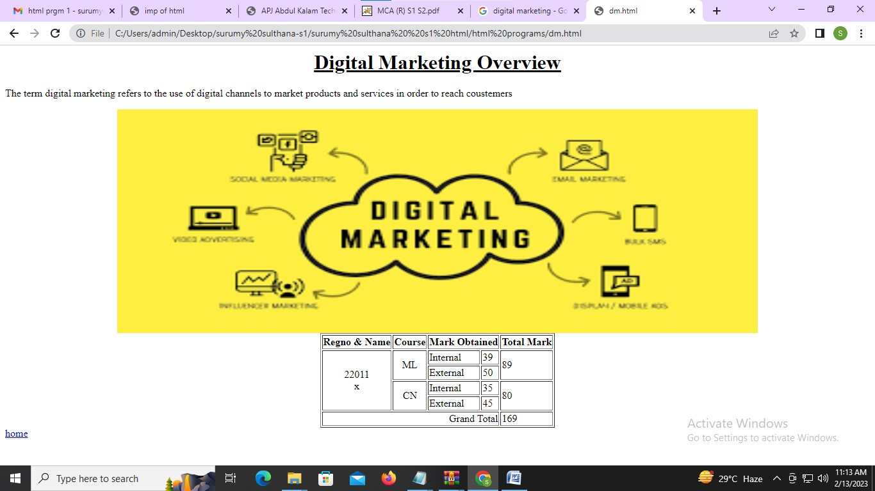

Program 3

Create a HTML page with different types of frames such as floating frame, navigation frame & mixed frame.

Program Code:

Frame.html

<html>

<head>

<title> MES </title>

</head>

<frameset rows="15%,85%">

<frame src="title.html">

<frameset cols="20%,80%">

<frame src="mca.html">

<frame src="right.html" name="frame3">

</html>

mca.html:

<html>

<body bgcolor="pink">

<CENTER><br><br><br><br><br><br><br><br><br><br><br><br><br><br>

<font color="blue" size="6">

<a href="dlt.html" target="frame3" > MCA </a>

</font>

</CENTER>

</BODY>

</HTML>

dlt.html

<html>

<body bgcolor="pink">

<center>

<font size="6" color="blue">

<b>

<u> Master Of Computer Application </u>

</b>

</font>

</center>

<font size="5"><br>

<P align="justify">Department of Computer Applications started in the year 1999 offers full-time Master of Computer Applications program. This was the first MCA program to be offered in the self-financing sector in Kerala. Since its inception, it had been producing technical graduates whose presence have spanned the entire spectrum of Information Technology in India and abroad.

</p>

</font><br><br>

<center>

<img src="C:\Users\admin\Desktop\surumy sulthana-s1\surumy sulthana s1 html\html programs\program3\mca.jpg" height="250" width="550 " >

</center><br>

<font size="5">

<P align="justify">MCA at MESCE is a two-year (Four Semester) professional master’s degree in Computer Applications under APJ Abdul Kalam Technological University. The course has been structured in line with the prevailing technology of the industry. It teaches theory and gives due importance to practical knowledge. This program understands the scope and standards of the industry and accordingly creates software engineers to the current demand of the Industry.

</p>

</font>

<font size="6" color="blue">

<b>VISION</b>

</font><br>

<font size="5">

<ul>

<li><P align="justify">To facilitate transformation of students into competent professionals with human values and social commitment.</p></li>

</ul>

</font><br><br>

<font size="6" color="blue">

<b>MISSION</b>

</font><br>

<font size="5" >

<ul>

<li><P align="justify">To equip students to face the industry challenges.</p></li>

<li><P align="justify">To inculcate leadership qualities, human values and social responsibilities in the youth to make them leaders in nation building.</p></li>

<li><P align="justify">To build research interest in students and thereby contribute meaningfully to the prosperity of the nation.</p></li>

</ul>

</font><br><br>

<font size="6" color="blue">

<b>Curriculum </B>

</FONT><BR>

<table border="1" bgcolor="lavender" size="3">

<tr>

<th rowspan="2">Semester</th>

<th colspan="2"> Courses Offered </th>

<th rowspan="2">Credit</th>

<th colspan="3"> Marks Distribution </th>

</tr>

<tr>

<th>Name</th>

<th>Category</th>

<th>CIE</th>

<th>ESE</th>

<th>Total</th>

</tr>

<tr>

<td align="center" rowspan="2"> I </td>

<td>MFC</td>

<td>Theory</td>

<td>4</td>

<td>40</td>

<td>60</td>

<td>100</td>

</tr>

<tr>

<td>WPLAB</td>

<td>Practical</td>

<td>2</td>

<td>50</td>

<td>50</td>

<td>100</td>

</tr>

<tr>

<td colspan="3"></td>

<td>6</td>

<td>90</td>

<td>110</td>

<td>200</td>

</tr>

</body>

</html>

Right.html

<html>

<body bgcolor="pink">

<font color="blue" size="6">

<b><u> ABOUT MESCE </u></b>

</FONT>

<P align="justify"><font size="5"> M.E.S College of Engineering, the first Engineering College established under the self financing sector in Kerala is

situated on the beautiful and serene banks of Nila or Bharathapuzha. It was established as an institution with minority

status in 1994.</p>

<center>

<img src="C:\Users\admin\Desktop\surumy sulthana-s1\surumy sulthana s1 html\html programs\program3\mesce.jpg" align="center" hight="500" width="500">

<font size="5">

<P align="justify">Widely acknowledged as one of the premier institutions imparting technical education in the state, the college offers admission to all categories of students with special consideration to educationally backward communities....</p>

</FONT>

</CENTER>

</BODY>

</HTML>

title.html

<html>

<body bgcolor="pink">

<CENTER><br>

<font color="blue" size="7"> MES COLLEGE OF ENGINEERING, KUTTIPURAM </font>

</CENTER>

</BODY>

</HTML>

Output:

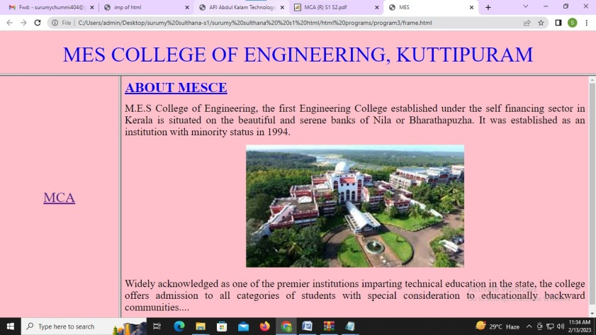

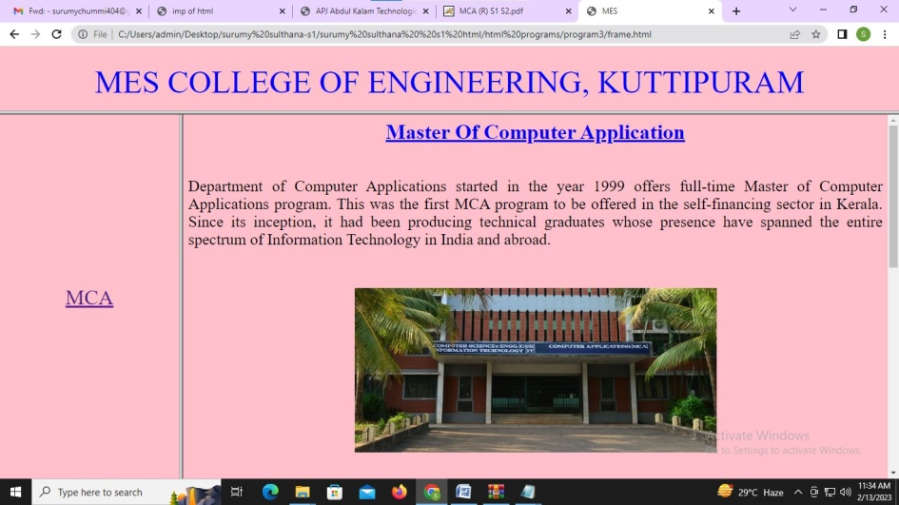

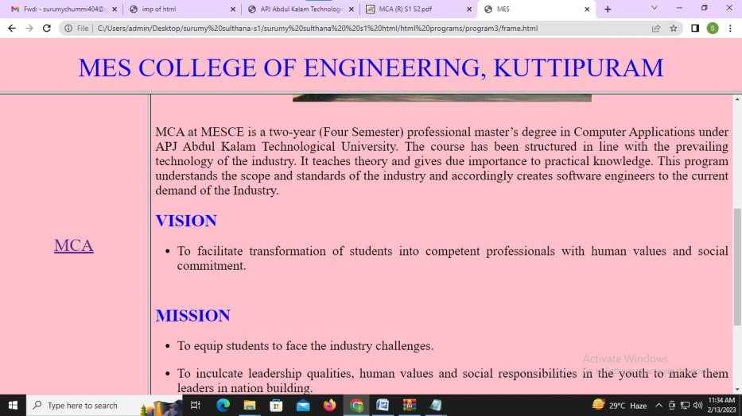

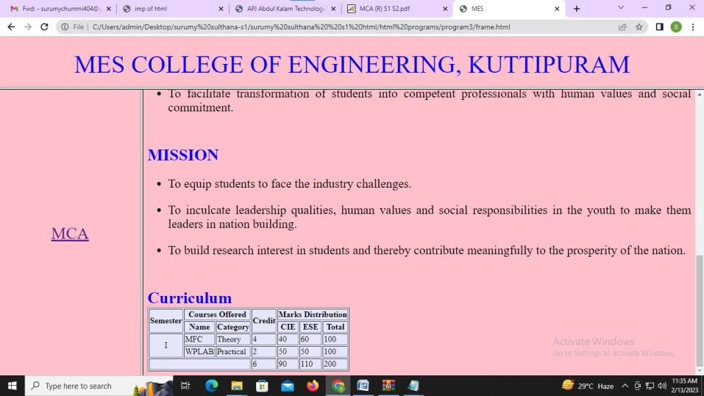

Program 4:

Analyze CSS by applying the different styles using inline, external & internal style sheets in a HTML file

Program Code:

Mainframe.html:

<html>

<head><title> mesframe</title></head>

<frameset rows="20%,*">

<frame src="topframe.html"/>

<frameset cols="20%,60%">

<frame name="left" src="leftframe.html"/>

<frame name="right" src="rightframe.html"/>

</frameset>

</frameset>

</html>

topframe.html:

<html>

<head></head>

<body style="background-color:beige;">

<center><h1 style="color:red;

border:2px dashed red;

padding:0.03em 0.25em;

background-color:pink;"><div style="

padding-top: 20px;

padding-right: 30px;

padding-bottom: 23px;

padding-left: 80px;">MES COLLEGE OF ENGINERRING, KUTTIPURAM</div></h1></center>

</body>

</html>

leftframe.html

<html>

<head>

<style>

body {

background-color:beige;

}

</style></head>

<br>

<br>

<br>

<br>

<br>

<br>

<br>

<br>

<br>

<br>

<br>

<br>

<br>

<br>

<br>

<center><a href="rightframe2.html" target="right"><font size="10">MCA</a><center>

</body>

</html>

rightframe.html:

<html>

<head>

<link rel="stylesheet" href="frame.css">

</head>

<body bgcolor="pink">

<h1>ABOUT MESCE</h1>

<p align="justify">

<font color="blue" size="4" >MES College of Engineering (MESCE) is a Kuttippuram, Malappuram-based private engineering college. It is Kerala's first self-financing engineering college, with campus that extends for more than a mile (1.6 km) along side the

Bharathappuzha River. It was founded in 1994 as a minority-serving institution.<br></p>

<p align="justify">

The college admits students from all backgrounds, with a special focus on educationally impoverished communities. The Fabrication Laboratory, the MES Innovation Centre, and the Community Development Centre are just a few of the institute's major off-campus facilities. The college currently offers eight undergraduate programmes, including a Bachelor of Architecture, as well as ten postgraduate programmes in Master of Engineering, Master of Computer Applications,

Master of Business Administration, and Master of Architecture.</p>

<center><img src="C:\Users\admin\Desktop\surumy sulthana-s1\surumy sulthana s1 html\mes.jpg" width="500" height="300"></center>

</font>

</body></html>

rightframe2.html:

<html>

<head>

<style>

#font1{

color:blue;

font-size: 40px;

}

.font2{

color:brown;

}

th

{

color:maroon;

}

table{

background-color:lightgray;

}

td

{

color:black;

}

img{

width: 200px;

height: 200px;

border-radius: 50%;

}

#p1

{

color:green;

}

#p2

{

color:red;

}

</style>

</head>

<body bgcolor="pink">

<center>

<b><font id="font1" >MASTER OF COMPUTER APPLICATIONS</b></font>

</center>

<p id="p1"align="justify"><font size="3" >

MCA at MESCE is a two-year (Four Semester) professional master’s degree in Computer Applications under APJ Abdul Kalam Technological University. The course has been

structured in line with the prevailing technology of the industry. It teaches theory and gives due importance to practical knowledge. This program understands the

scope and standards of the industry and accordingly creates software engineers to the current demand of the Industry.</font></p>

<center><img src="C:\Users\admin\Desktop\surumy sulthana-s1\surumy sulthana s1 html\mca.jpg" ></center>

<p id="p2" align="justify"><font size="3" >

The department is guided by eminent faculty and instructors and has the state-of-the-art lab facilities and infrastructure. The department library houses sufficient

books and reference materials needed for the course and are available from 8AM to 8PM. The lab facilities are open from 8AM to 8PM for honing the technical skills of

the students. With a professional faculty and tech savvy environment, students can study and master the required skills for a professional and competitive world.

</p>

<P>

<ul>

<b><font class="font2" size="5" >VISION</font></br> </b>

<font size="3" color="blue"><li>To facilitate transformation of students into competent professionals with human values and social commitment.</li> </font></br></p>

<P> <b><font class="font2" size="5" >MISSION </font></br> </b>

<font size="3" color="blue"><li>To equip students to face the industry challenges</li></br><li>To inculcate leadership qualities, human values and social responsibilities in the youth to make them leaders in nation building</li>.</br><li>To build research interest in students and thereby contribute meaningfully to the prosperity of the nation</li>.</font></br>

</P>

</ul>

<b><font size="5" color="blue">Curriculam</font></b></br>

<table border="1">

<tr>

<th rowspan="2">Semester</th>

<th colspan="2"> Courses Offered</th>

<th rowspan="2">Credit</th>

<th colspan="3">Mark Discription</th>

</tr>

<tr>

<th>Name</th>

<th>Category</th>

<th>CIE</th>

<th>ESE</th>

<th>Total</th>

</tr>

<tr>

<td rowspan="2">i</td>

<td>MFC</td>

<td>Theory</td>

<td>4</td>

<td>40</td>

<td>60</td>

<td>100</td>

</tr>

<tr>

<td>WPLAB</td>

<td>Practical</td>

<td>2</td>

<td>50</td>

<td>50</td>

<td>100</td>

</tr>

<tr>

<td colspan="3"></td>

<td>6</td>

<td>90</td>

<td>110</td>

<td>200</td>

</table>

</body>

</html>

frame.css

body {

background-color: beige;

}

h1 {

color: red;

}

p{

color:navy;

}

font{

color:navy;

}

Output:

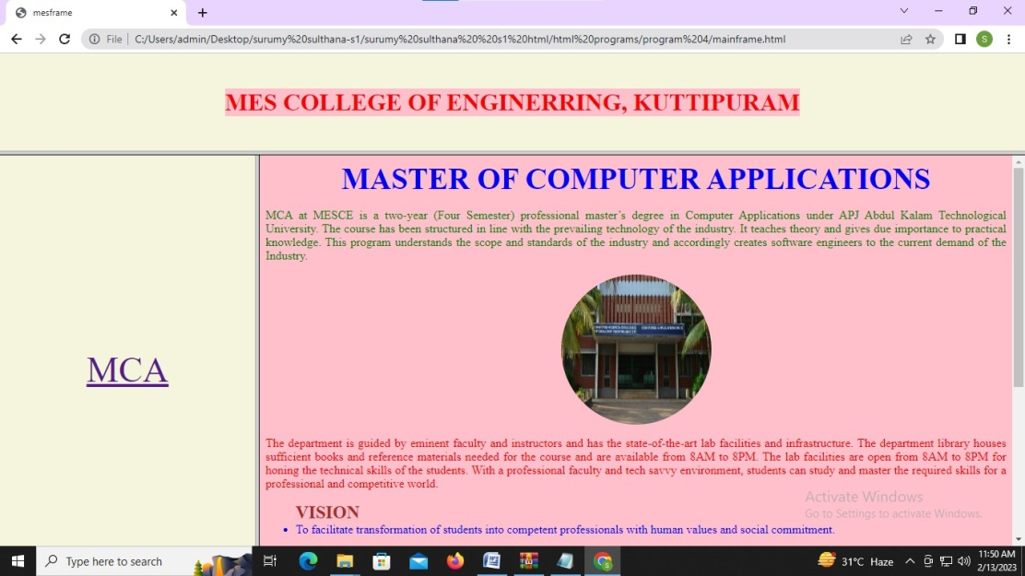

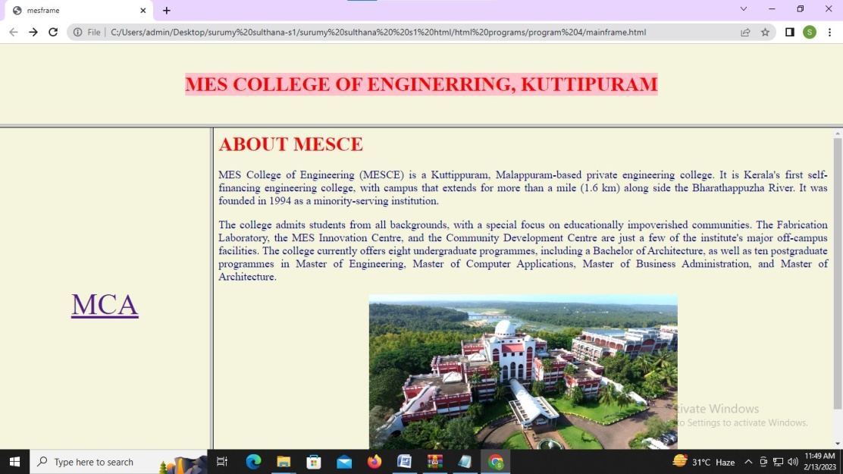

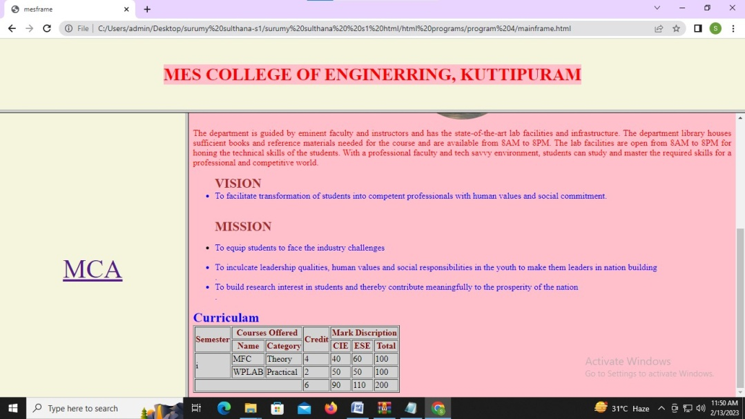

Program 5:

Demonstrate a registration form using HTML.

Program code:

<html>

<head>

<title>form</title>

<style>

.right

{

position:relative;

left:700px;

color:brown;

}

.body

{

background-color:powderblue;

}

.ad

{

position:relative;

left:-7;

}

.gen

{

position:relative;

left:1;

}

.date

{

position:relative;

left:-28;

}

.fl

{

width:500;

background-color:lavender;

}

.h3

{

position:absolute;

left:650;

top:370;

}

.h3_sub

{

position:absolute;

left:650;

top:395;

}

.other

{

position:relative;

left:50;

}

</style>

</head>

<body class="body">

<h2 class="right">Registration Form</h2>

<center>

<form>

<fieldset class="fl">

<legend align="left"><h3>Persional Information</h3></legend>

<label>Name : </label>

<select>

<option>Mr.</option>

<option>Ms.</option>

</select>

<input type="text" name="name" value="Enter Your Name" size="13"><br><br>

<label>Email : </label> <input type="email" name="email" value="eg;example@gmail.com"><br><br>

<label class="ad">Address : </label> <textarea class="ad" cols="21" rows="5" name="address" "></textarea><br><br>

<label class="gen">Gender : </label>

<input class="gen" type="radio" name="gender"><label class="gen">Male</label>

<input class="gen" type="radio" name="gender"><label class="gen">Female</label>

<input class="gen" type="radio" name="gender"><label class="gen">Other</label> <br><br>

<label class="date">DOB : </label> <input class="date" type="date" name="dob">

</fieldset>

</center>

<h3 class="h3">Languages Known</h3><br>

<p class="h3_sub">

<input type="checkbox" name="eng"> <label>English</label><br>

<input type="checkbox" name="mala"> <label>Malayalam</label><br>

<input type="checkbox" name="hin"> <label>Hindi</label><br><br>

<label>Select a File</label> <button value="choose"> Choose </button><br><br>

<input type="submit" name="submit" value="Submit"> <input type="reset" name="reset" value="Reset">

</p>

</form>

</body>

</html>

Output:

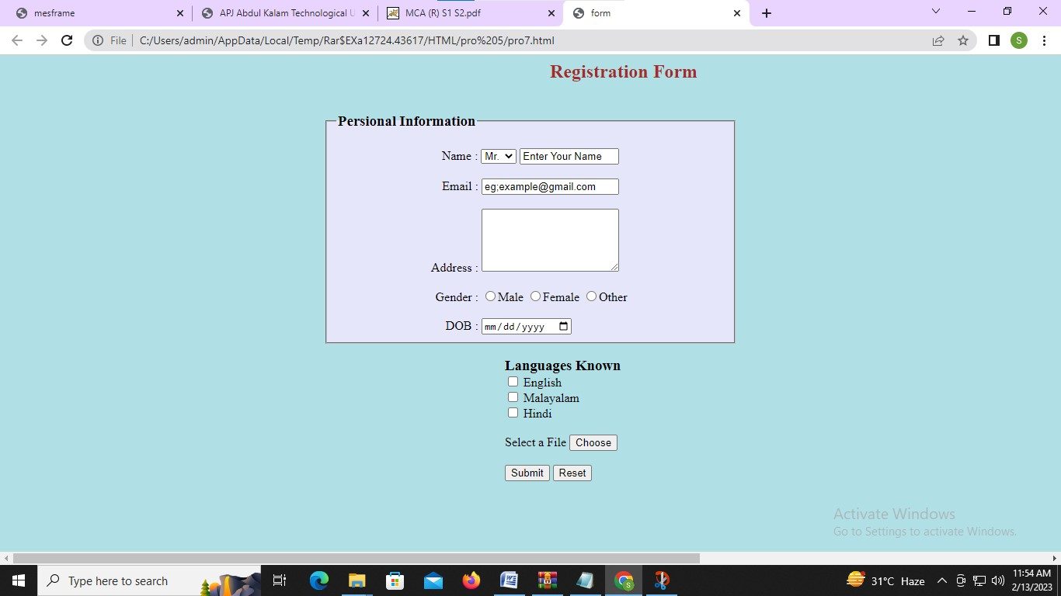

Program 6:

Outline a registration form using PHP and do necessary validations.

Program code:

<?php

$nameError = $emailError = $genderError = $phonenoError ="";

$name = $email = $gender = $phoneno = $comment = "";

if($_POST){

if (empty($_POST["name"])) {

$nameError = "Name is required";

} else {

$name = test_input($_POST["name"]);

if (!preg_match("/^[a-zA-Z ]*$/",$name)) {

$nameError = "Only letters and white space allowed";

}

}

if (empty($_POST["email"])) {

$emailError = "Email is required";

} else {

$email = test_input($_POST["email"]);

if (!filter_var($email, FILTER_VALIDATE_EMAIL)) {

$emailError = "Invalid Email format";

}

}

if (empty($_POST["phoneno"])) {

$phonenoError = "Phone is required";

} else {

$phoneno = test_input($_POST["phoneno"]);

if(!preg_match("/^[0-9]{10}+$/", $phoneno)) {

$phonenoError= "Invalid Phone Number";

}

}

if (empty($_POST["comment"])) {

$comment="";

} else {

$comment = test_input($_POST["comment"]);

}

if (empty($_POST["gender"])) {

$genderError = "Gender is required";

} else {

$gender = test_input($_POST["gender"]);

}

}

function test_input($data) {

$data = trim($data);

$data = stripslashes($data);

$data = htmlspecialchars($data);

return $data;

}

?>

<html>

<head>

<title>Form Validation with PHP</title>

<style>

.error{

color:red

}

textarea{

width:250px;

height:60px;

border:none

}

.input{

width:300px;

height:25px;

margin-top:10px;

border:none;

}

form{

position:relative;

left:500;

width:440px;

padding: 20px ;

background-color:#a0f8ee;

}

</style>

</head>

<body>

<h2 align = "center">Form Validation with PHP</h2>

<form method="post">

<h2>Registration Form</h2>

<span class="error">* required field</span><br>

<span class="error">*</span>

Name:

<input class="input" name="name" type="text" value="<?= $name ?>"><br>

<span class="error"><?php echo $nameError;?></span><br><br>

<span class="error">*</span>

E-mail:

<input class="input" name="email" type="text" value="<?= $email ?>"><br>

<span class="error"><?php echo $emailError;?></span><br><br>

<span class="error">*</span>

Phone:

<input class="input" name="phoneno" type="text" value="<?= $phoneno ?>"><br>

<span class="error"><?php echo $phonenoError;?></span><br><br>

<span class="error">*</span>

Gender:

<input type="radio" name="gender" <?php if (isset($gender) && $gender == "female") echo "checked";?> value="female">Female

<input type="radio" name="gender" <?php if (isset($gender) && $gender == "male") echo "checked";?> value="male">Male

<input type="radio" name="gender" <?php if (isset($gender) && $gender == "other") echo "checked";?> value="other">Other<br>

<span class="error"><?php echo $genderError;?></span><br><br>

Comment:

<textarea cols="40" name="comment" rows="5">

</textarea><br><br>

<input name="submit" type="submit" value="Submit">

</form>

<?php

echo "<h1>Your Input:</h1><h2>";

echo $name;

echo "<br>";

echo $email;

echo "<br>";

echo $phoneno;

echo "<br>";

echo $gender;

echo "<br>";

echo $comment."</h2>";

?>

</body>

</html>

Output:

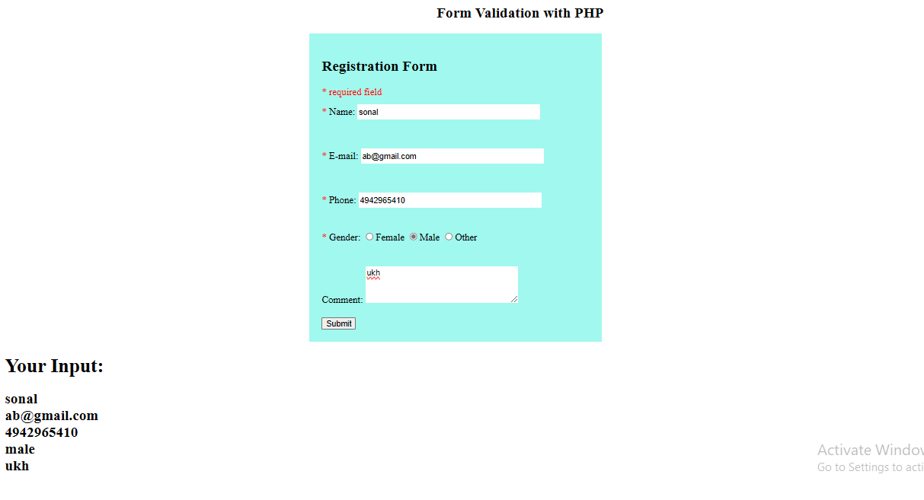

Program 7:

Compose Electricity bill from user input based on a given tariff using PHP.

Program code:

<html>

<head><style>input{border:solid 2px; padding:5px;font-size: 28px;}</style></head>

<body>

<h1>Php - Calculate Electricity Bill</h1>

<form method="post">

<input type="number" width="10px" name="units" placeholder="Please enter no. of Units" />

<input type="submit" name="unit-submit" value="Submit" />

</form>

</body>

<?php

$result_str = $result = '';

if (isset($_POST['unit-submit'])) {

$units = $_POST['units'];

if (!empty($units)) {

$result = calculate_bill($units);

$result_str = '<h2>Total amount of ' . $units . ' - ' . $result."</h2>";

echo $result_str;

}

}

function calculate_bill($units) {

$unit_cost_first = 3.50;

$unit_cost_second = 4.00;

$unit_cost_third = 5.20;

$unit_cost_fourth = 6.50;

if($units <= 50) {

$bill = $units * $unit_cost_first;

}

else if($units > 50 && $units <= 100) {

$temp = 50 * $unit_cost_first;

$remaining_units = $units - 50;

$bill = $temp + ($remaining_units * $unit_cost_second);

}

else if($units > 100 && $units <= 200) {

$temp = (50 * 3.5) + (100 * $unit_cost_second);

$remaining_units = $units - 150;

$bill = $temp + ($remaining_units * $unit_cost_third);

}

else {

$temp = (50 * 3.5) + (100 * $unit_cost_second) + (100 * $unit_cost_third);

$remaining_units = $units - 250;

$bill = $temp + ($remaining_units * $unit_cost_fourth);

}

return number_format((float)$bill, 2, '.', '');

}

?>

</html>

Output:

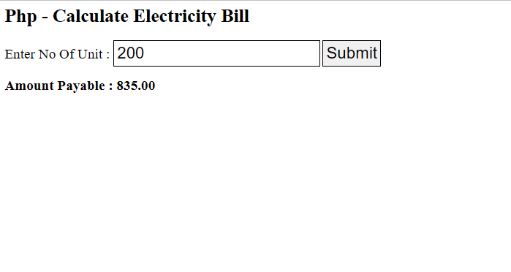

Program 8

Build a PHP code to store name of students in an array and display it using print_r function. Sort and Display the same using asort & arsort functions.

Program code:

<?php

$students=array("pra"=>"pranav","sha"=>"shaheen","mid"=>"midun","fala"=>"falahu","mush"=>"mushfique");

echo "<h2>";

print_r($students);

echo "<br><br>";

echo "The Array sorted using asort : <br>";

asort($students);

print_r($students);

echo "<br><br>";

echo "The Array sorted using arsort : <br>";

arsort($students);

print_r($students);

echo "</h2>";

?>

Output:

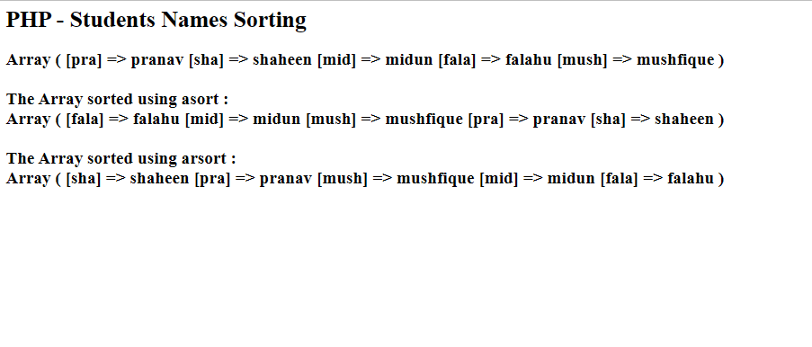

Program 9:

Build a PHP code to store name of Indian Cricket players in an array and display the same in HTML table.

Program code:

<html>

<head>

<style>

.c

{

border: solid 1px; font-size:28px; padding: 3;}

</style>

</head>

<body>

<?php

$data= array(array('1','Sachin','Tendulkar'),array('2','Virat','Kohli'),array('3','MS','Dhoni'));

echo "<h1> Indian Cricket players </h1>";

echo "<table class=c>";

echo "<tr class=c><th class=c>NO</th><th class=c>First Name</th><th class=c>Last Name</th></tr>";

foreach ($data as $a)

{

echo "<tr class=c>";

foreach($a as $v)

{

echo "<td class=c>".$v."</td>";

}

echo "</tr>";

}

echo "</table>";

?>

</body>

</html>

Output:

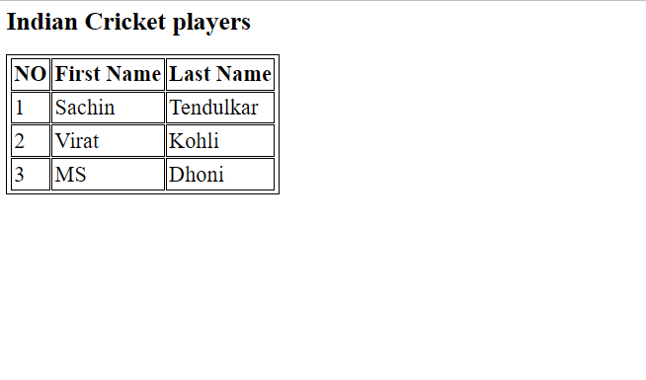

Program 10:

Develop a PHP program to connect to a database and retrieve data from a table and show the details in a neat format

Program code:

<?php

$con=mysqli_connect("localhost","root","","college");

if(!$con)

{

echo "connection failed.!";

}

$result=$con->query("select * from students");

if($result==false)

{

echo "query failed.!";

}

else

{

echo "<h1><u> PHP - Database Connection </u></h1>";

while($row=$result->fetch_object())

{

echo "<h2>".$row->studname." , ".$row->email." , ".$row->dob."</h2>";

}

}

?>

**SQL (RUN ON PHPMYADMIN)**

CREATE DATABASE college;

CREATE TABLE students (id int PRIMARY KEY AUTO_INCREMENT , studname varchar (50) , email varchar ( 50) , dob date);

INSERT INTO students (id,studname,email,dob) VALUES (NULL, ‘ falahudeen p t’,’falahuddeen121@gmail.com’,’2000-10-27’);

INSERT INTO students (id,studname,email,dob) VALUES (NULL, ‘nimitha’,’nimitha@gmail.com’,’2001-01-18’);

Output:

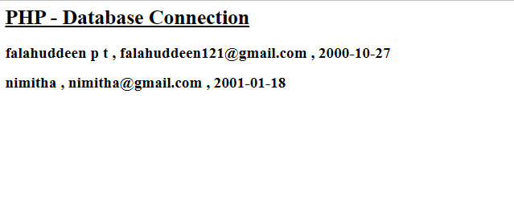

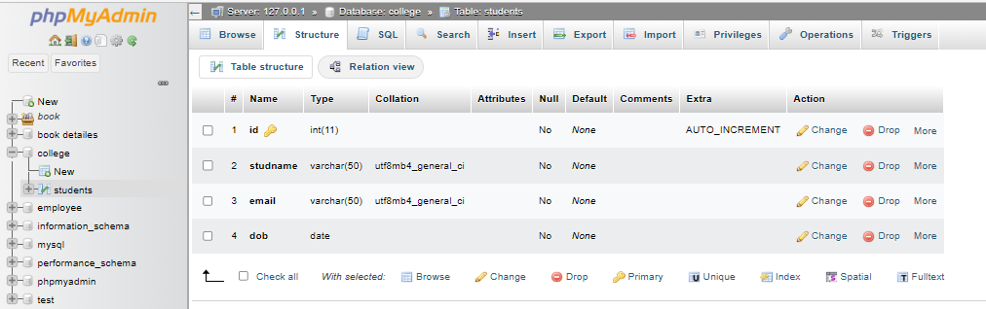

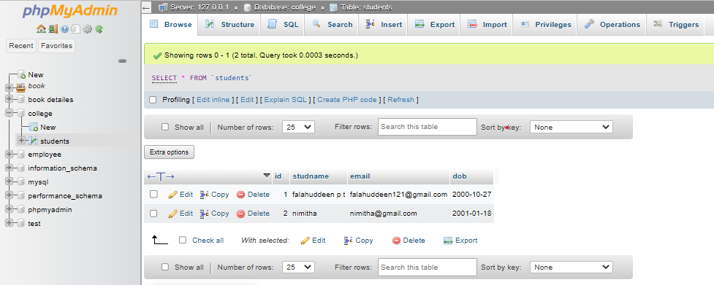

Program 11:

Create a HTML page to explain the use of various predefined functions in a string and math object in java script

Program code:

<html>

<body>

<p id="demo"></p>

<script>

document.write("<h3>STRING FUNCTIONS</h3>")

var string = "HELLO WELCOME TO HTML";

document.write("The string is:"+string);

var length=string.length;

document.write("</br></br>Length of the string<b>'string.slice(6,13)'</b>:"+length);

var slice=string.slice(6,13);

document.write("</br></br>After string slicing:"+slice);

var replace= string.replace("HTML","JAVA");

document.write("</br></br>After after replacing html to java:"+replace);

var tolower=string.toLowerCase()

document.write("</br></br>After after the string to lowercase:"+tolower);

var toupper=tolower.toUpperCase()

document.write("</br></br>After after the string to uppercase:"+toupper);

var round=Math.round(4.6);

document.write("</br></br>After round"+round);

document.write("<h3>STRING FUNCTIONS</h3>")

var ceil =Math.ceil(5.8);

document.write("<BR>Math Object Ceil <b>'Math.ceil(3.5)'</b> : "+ceil);

var floor =Math.floor(6.8);

document.write("<BR><br>Math Object Floor <b>'Math.floor(3.5)'</b> : "+floor);

var power = Math.pow(8,2);

document.write("<BR><br>Math Object Power <b>'Math.pow(8,2)'</b> : "+power);

var pi=Math.PI;

document.write("<BR><br>Math Object PI <b>'Math.PI'</b> : "+pi);

</script>

</body>

</html>

Output:

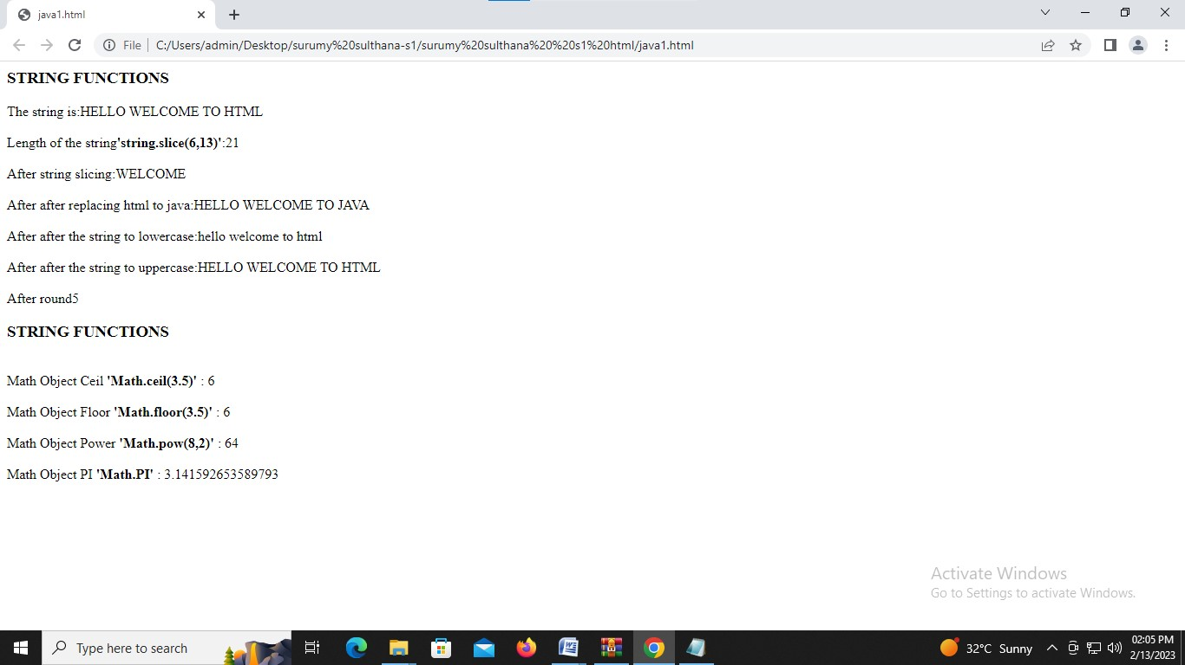

Program 12:

Generate the calendar using JavaScript code by getting the year from the user.

Program code:

<html>

<body>

<style>

table,

th,

tr,

td {

border: 2px solid;

padding: 2px 3px;

text-align: center;

}

table {

width: 60%;

}

th {

background-color: aquamarine;

}

</style>

<script>

function cal()

{

var mnth = document.getElementsByName('inputMnth')[0].value;

var year = document.getElementsByName('inputYear')[0].value;

var heading = document.getElementById('heading');

var dateString = mnth + " 1," + year;

heading.innerHTML = mnth.toUpperCase() + " &nbsp;" + year;

var tb = document.getElementById("t");

var dt = new Date(dateString);

var cellNum = dt.getDay();

const mnth31 = ["january", "march", "may", "july", "august", "october", "december"];

const mnth30 = ["april", "june", "september", "november"];

var count = 1;

for (var i = 1; i < 6; i++)

{

var cel = tb.rows.item(i).cells;

for (var j = cellNum; j < 7; j++)

{

cel.item(j).innerText = count++;

if (mnth31.includes(mnth.toLowerCase()))

{

if (count > 31)

break;

}

else if (mnth30.includes(mnth.toLowerCase()))

{

if (count > 30)

break;

}

else if (mnth == "February")

{

if (year % 400 == 0 || year % 4 == 0 && year % 100 != 0)

{

if (count > 29)

{

break;

}

}

else

{

if (count > 28)

{

break;

}

}

}

else

{

document.write("Enter Valid Month");

return 0;

}

}

cellNum = 0;

}

}

</script>

<center>

<label>Enter Month </label> &nbsp; &nbsp;

<input type="textbox" name="inputMnth"><br><br>

<label>Enter Year </label>&nbsp; &nbsp; &nbsp; &nbsp;

<input type="textbox" name="inputYear"><br><br>

&nbsp; &nbsp; &nbsp; &nbsp; &nbsp; &nbsp; &nbsp; &nbsp; &nbsp; &nbsp; &nbsp; &nbsp;

<button onClick="cal()">submit</button><br><br><br>

<b>

<h2><label id="heading"></label></h2>

</b>

<!-- <button onClick="showtable1()">submit</button> -->

<table id="t">

<th style="color: red;">Sun</th>

<th>Mon</th>

<th>Tue</th>

<th>Wed</th>

<th>Thu</th>

<th>Fri&nbsp; </th>

<th>Sat&nbsp; </th>

<tr style="background-color: rgb(186, 248, 248);">

<td style="color: red;">&nbsp;</td>

<td> </td>

<td> </td>

<td> </td>

<td> </td>

<td> </td>

<td> </td>

</tr>

<tr style="background-color: rgb(121, 242, 216);">

<td style="color: red;">&nbsp;</td>

<td> </td>

<td> </td>

<td> </td>

<td> </td>

<td> </td>

<td> </td>

</tr>

<tr style="background-color: rgb(186, 248, 248);">

<td style="color: red;">&nbsp;</td>

<td> </td>

<td> </td>

<td> </td>

<td> </td>

<td> </td>

<td> </td>

</tr>

<tr style="background-color: rgb(121, 242, 216);">

<td style="color: red;">&nbsp;</td>

<td> </td>

<td> </td>

<td> </td>

<td> </td>

<td> </td>

<td> </td>

</tr>

<tr style="background-color: rgb(186, 248, 248);">

<td style="color: red;">&nbsp;</td>

<td> </td>

<td> </td>

<td> </td>

<td> </td>

<td> </td>

<td> </td>

</tr>

</table>

</center>

</body>

</html>

Output:

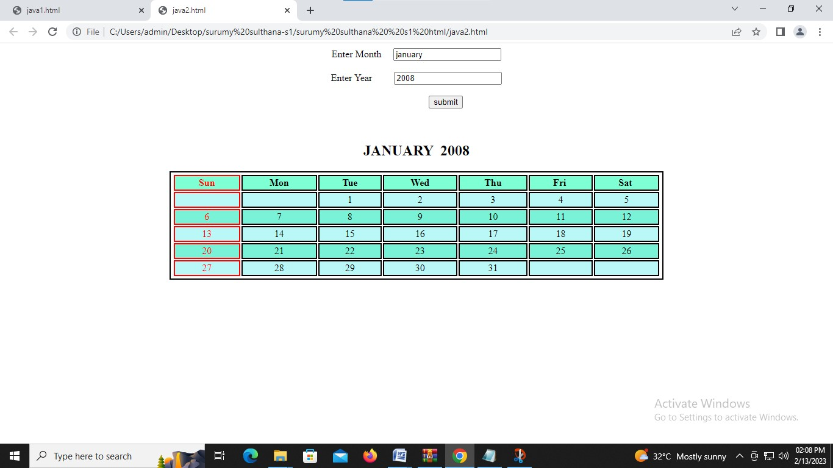

Program 13:

Create a HTML registration form and to validate the form using JavaScript code.

Program code:

<!DOCTYPE html>

<html>

<head>

<title>Welcome To Registration Form</title>

<script>

function registration()

{

var name= document.getElementById("t1").value;

var phone= document.getElementById("t2").value;

var g1=document.getElementById("g1").checked;

var g2=document.getElementById("g2").checked;

var g3=document.getElementById("g3").checked;

var comment= document.getElementById("c1").value;

var phoneno = /^\d{10}$/;

var letters = /^[A-Za-z]+$/;

if(name=='')

{

alert('Please enter your name.!');

}

else if(!letters.test(name))

{

alert('Name field required only alphabet characters.!');

}

else if(phone=='')

{

alert('Please enter your phone number.!');

}

else if (isNaN(phone))

{

alert('Invalid Phone Number.!');

}

else if (!phoneno.test(phone))

{

alert('Not Valid Phone Number (need 10 digits).!');

}

else if ((g1=="")&&(g2=="")&&(g3==""))

{

alert('You must select Gender');

}

else

{

alert('Thank You for Registration & You are Redirecting to Website');

}

}

</script>

</head>

<body>

<center>

<h2>Register Form Validation</h2>

<form style="width:500px;position: relative;left: 500;" >

<fieldset " >

<legend>Validation</legend>

<table cellspacing="2" align="center" cellpadding="8" border="0">

<tr>

<td align="right">Enter Name :</td>

<td><input type="text" placeholder="Enter name here" id="t1"></td>

</tr>

<tr>

<td align="right">Enter Phone Number :</td>

<td><input type="text" placeholder="Enter Phone Number here" id="t2"> </td>

</tr>

<tr>

<td align="right">Gender :</td>

<td><input type="radio" name="gender" value="male" id="g1"> Male

<input type="radio" name="gender" value="female" id="g2"> Female

<input type="radio" name="gender" value="other" id="g3"> Other</td>

</tr>

<tr>

<td align="right">Comment :</td>

<td><textarea cols="20" rows="5" name="comment" id="c1"></textarea></td>

</tr>

<tr>

<td></td>

<td>

<input type="reset" value="Clear Form" id="res">

<input type="submit" value="Create Account" onclick="registration()" /></td>

</tr>

</table>

</fieldset>

</form>

</center>

</body>

</html>

Output:

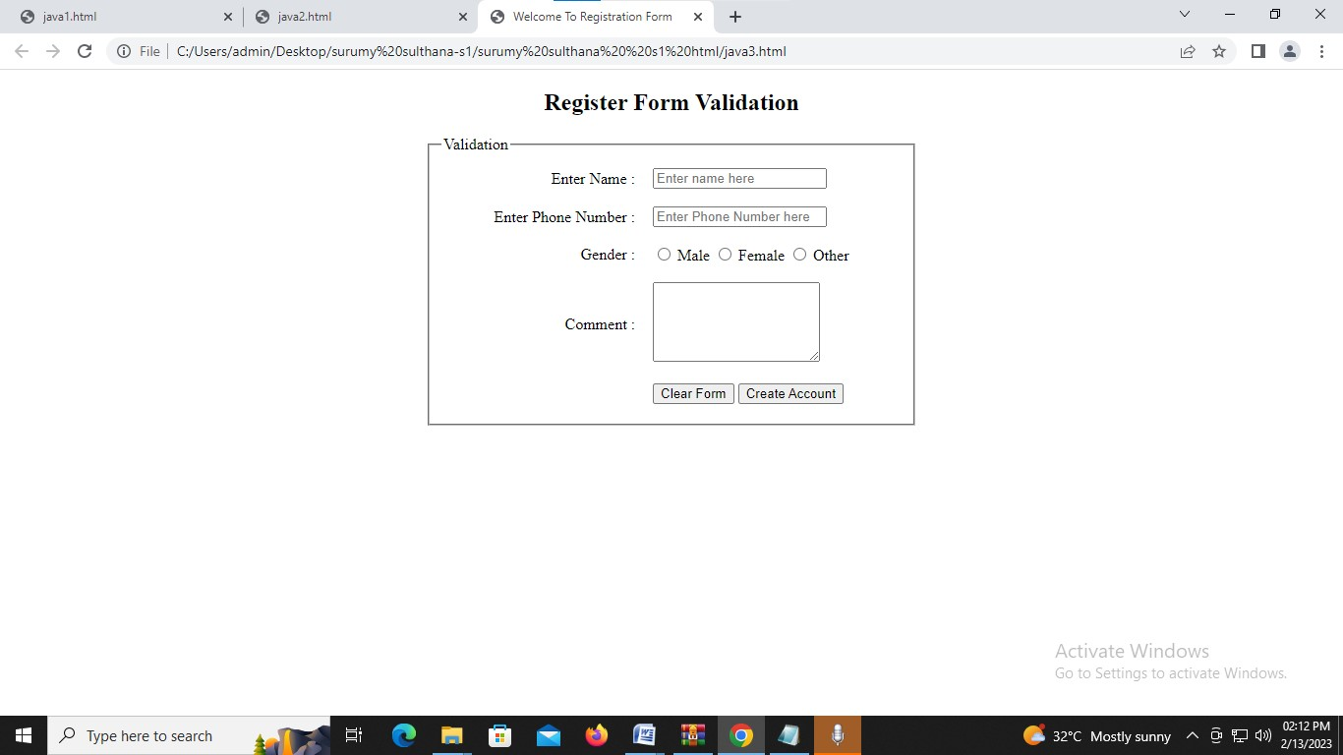

Program 14:

Create a HTML page to change the background color for every click of a button using JavaScript Event

Program code:

<html>

<head>

<script>

function myFun()

{

var r=Math.floor(Math.random()*256);

var g=Math.floor(Math.random()*256);

var b=Math.floor(Math.random()*256);

document.body.style.backgroundColor="rgb("+ r +","+ g +","+ b +")";

}

</script>

<style>

button

{

position: absolute;

top: 50%;

left: 50%;

padding: 15px;

font-size: 15px;

}

</style>

</head>

<body>

<button onclick="myFun()">Change Color</button>

</body>

</html>

Output:

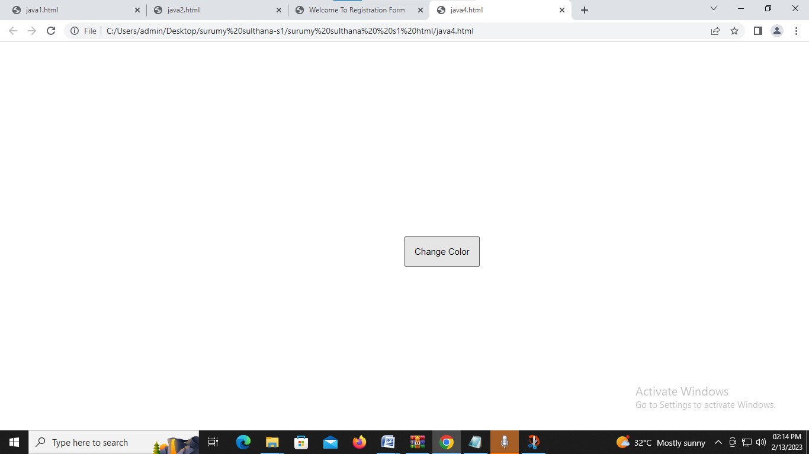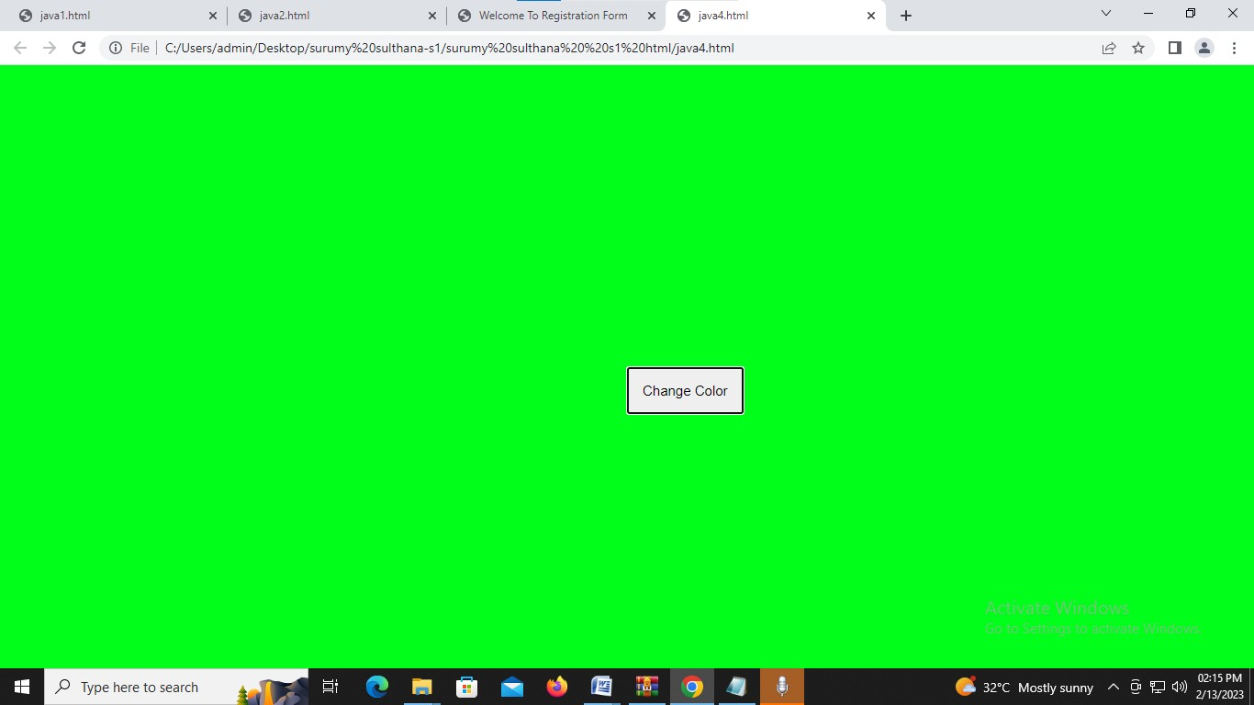

Program 15:

.Create a HTML page to display a new image and text when the mouse comes over the existing content in the page using JavaScript Event Handling.

Program code:

<html>

<body>

<style>

img

{

position: absolute;

left:460;

top:50;

border-radius: 700px;

height: 590px;

width: 590px;

}

p

{

position: relative;

top: 650;

left: 630;

font-size: 28px;

}

</style>

<script>

function first()

{

document.getElementById("img").src="img1.jpeg";

document.getElementById("p").innerHTML="<font color=magenta>NOW onmouseover</font>";

}

function second()

{

document.getElementById("img").src="img2.jpeg";

document.getElementById("p").innerHTML="<font color=red>NOW onmouseout</font>";

}

</script>

<img src="img3.jpeg" id="img" onmouseover="first()" onmouseout="second()">

<b><p id="p"></p></b>

</body>

</html>

Output:

